vi
Vi is a powerful text editor in linux . vi has three modes: command mode , insert mode and last line mode . In command mode, user input will be thinked as command. In insert mode, user input is content of text. In last line mode , user can type commands such as w ,wq ,q to quit vi.vi starts in command mode.
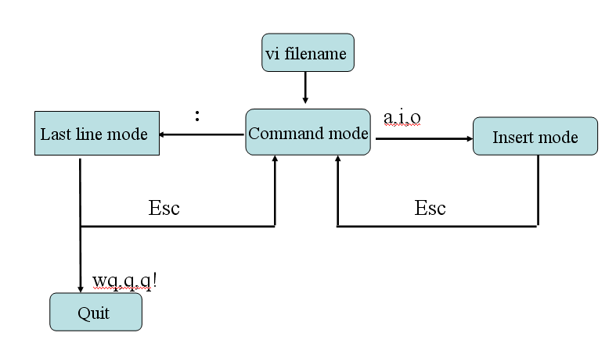
1 How to input text in vi?
After vi starts , type a or i or o to enter insert mode. Then you can input text .

2.How to quit vi?
(1) enter last line mode , type wq #save and quit
(2) enter last line mode , type q # quit after you have saved your work
(3) enter last line mode , type q! # quit without save what you work.

3 How to save my work without quit?
Enter last line mode , type w

4 How to find a string in vi ?
For example , If you want to find “apple” in text , enter command mode and type “/apple”or “?apple”. The string apple will be highlighted and you can press n or N to move from one to another.

5. How to copy and paste in vi ?
(1) In command mode, type yy to copy current line to buffer
(2) In command mode, type p or P to paste the line you just copied

6. How to delete line in vi
(1) In command mode, type dd to delete current line
(2) In command mode, type n dd to delete n lines starting from the current cursor
Position. For example “3 dd” to delete 3 lines from current cursor.

7. How to show line number in vi ?
(1) In last line mode ,type “set number” to show line number
(2) In last line mode ,type “set nonumber” to hide line number
8 How to move cursor quickly?
In command mode
(1) 0: move cursor to head of current line
(2) $: move cursor to tail of current line
(3) ctrl d: move cursor down to 18 lines
(4) ctrl u: move cursor up to 18 lines
(5) nG: go to line number n directly , for example 10G will go to line 10 directly

9. How to undo and redo in vi
(1) undo: In command mode, type u
(2) redo: In command mode, type .

10. Exercise 1
Create a file named linux, the content is following:
Linux is a free open-source operating system based on Unix.
Linux was originally created by Linus Torvalds
Linux is free to download, edit and distribute.
Linux is a free open-source operating system based on Unix.

- set number for this file
- find all “Linux” and change them to “Unix”
- save and quit

11. Exercise 2
Write a C program whose function is as follows：input an int type number from keyboard, then print the value of the variable you just input to screen.

Gcc
Gcc is GNC project C and C++ compiler in Linux. When you invoke GCC，it normally does preprocessing, compilation, assembly and linking. The first three stages apply to an individual source file, and end by producing an object file, linking combines all the object files into executable file.
For any given input file, the file name suffix determines what kinds of compilation is done. Filename.c stand for C source code.
The most commonly used option introduction:

gcc source.suffix –o sourc.o, the object file for souce.suffix in source.o.
if –o is not specified, the default is to put an executable file in a.out.
For example:
(1)write a C source file: vi test.c
(2)compile the source file into an executable file: gcc test.c –o test.o
(3)execute : ./test.o

Exercise：type a C program whose function is : get a integer data from keyboard, if the data is larger than 1, print “I am parent ” ,else if the data is equal to 0,then print “I am the child ”.

Vi test3.c

Exercise 1
Create a file named linux, the content is following:
Linux is a free open-source operating system based on Unix.
Linux was originally created by Linus Torvalds
Linux is free to download, edit and distribute.
Linux is a free open-source operating system based on Unix.

(1)set number for this file
(2)find all “Linux” and change them to “Unix”
(3)save and quit

Exercise 3
Type a C program named cTest4.c whose function is : calculate the value of 1+2+3+….+1000.
Requirement:
(1)use loop structure in C programming to accomplish the problem.
(2)Compile the source file and run it.

